Term Paper

Economics 8456-001

Monetary Theory and policy

**An Analysis of the Federal Reserve’s Interest Rate Targeting**

Submitted by: Lucas Wagoner

To

Professor Mark Wohar

Date: April 8, 2019

**An Analysis of the Federal Reserve's Interest Rate Targeting.**

**Section 1 Introduction**

In response to the Great Recession, the Federal Reserve leveraged its monetary policy tools to spur economic activity. The Federal Funds rate was slashed to near zero and the Federal Reserve also began Quantitative Easing wherein they purchased a large amount of treasury securities and US government backed mortgage securities. In the years following the recession, the economy has grown slowly but steadily and is currently close to full employment with low levels of inflation. As the economy reaches full employment and uses up excess capacity, wages rise and prices should accelerate, making it necessary to curb any ‘overheating’ with higher interest rates to slow risky borrowing. Although the inflationary pressures did not materialize, the Federal Reserve would eventually pursue normalization of the federal funds rate to bring the target rate closer to historical levels.

In 2016, after 8 years of low but positive expansion, the Federal Reserve Committee decided they could no longer wait for the economy to produce inflationary pressures to justify rate increases and embarked on a policy of Federal Funds interest rate hikes to bring the Federal Funds target range of interest rates closer to historical levels. The Federal Reserve thus began the policy of ‘normalization’ with interest rate hikes under the guidance of then-chairman Janet Yellen. In early 2018, Jerome Powell assumed the chair and the Federal Reserve greatly increased their outlook on the economy based off of a sharp upturn in global growth, low unemployment domestically and fiscal stimulus measures in the form of tax cuts and increased government spending. At the time, most Federal Reserve officials projected three rate increases in 2019 with the possibility for an additional increase in 2020 to bring the federal funds target range to be between 3.25% and 3.5%.[1] The policy guidance was intended to increase the Federal Funds rate to a ‘neutral’ interest rate range where policy does not stimulate or slow the economy. The Federal Reserve ultimately did institute a number of interest rate increases in 2018, bringing the Federal Funds target range to 2-2.25% where it sits currently.In the most recent Federal Open Market Committee, the US Federal Reserve Bank announced they would halt raising its federal funds rate rate for the rest of 2019 as well as suggesting minimal, if any, further increases in 2020 or even 2021[2].

**Section 1.2 An analysis of the ‘normalization’ policy**

This policy of ‘normalization’ seemed justified. The aforementioned tax cut measures led to a sharp rise in after-tax profits for US corporations (See Figure 1) and an apparent pick-up in US real GDP growth, reaching around a 3.5% growth rate at the end of 2018[3]. Nearly one year later, forecasts for growth have been changed. Research by Robert Barro and Jason Furman provides evidence that the tax cuts are boosting short-term results but the effects will not carry over long-term.[4] Their research found new orders and investment did pick up when the measures were initiated but fell below previous trends in 2018, undermining claims the tax-cuts would provide a long-term boost in investment spending. Additionally, A year ago, the Federal Reserve had raised its real GDP growth forecast for the whole of 2018 to 2.7% and 2.4% for 2019. Now at its March 2019 meeting, it has lowered its forecast for 2019 to 2.1% and just 1.9% for 2020, slowing again to just 1.8% in 2021 – well below the boasted 3%-plus President Trump claims his tax measures would achieve permanently[5]. In addition to the Federal Reserve pausing its rate hiking, they have also announced an end to the monetary tightening policy of running down its holdings of government bonds that it had built up as part of the ‘quantitative easing’ program, launched in the Great Recession. What has happened over the last year to cause the Federal Reserve officials to halt their projected rate increases and even consider lowering the target rate? Federal Reserve officials have cited the difficulty of quantifying political risks, recent weak U.S. economic data, including soft inflation, and slowing growth as reasons to hold off on more rate increases for a while as they assess the health of the expansion. In addition, the so-called neutral rate, where monetary policy is neither accommodative nor tightening, has gradually lowered to a level where officials may feel further interest rate increase are unnecessary. The remainder of this paper will explore these issues in more detail. Section 2 will very briefly discuss some political turmoil causing uncertainty such as the Trump Administration's trade disputes and issues in the European economy. Section 3 will address inflation and unemployment, addressing the Phillips Curve unemployment inflation trade off. Section 4 will provide a discussion of the neutral rate. Section 5 will present arguments for the Federal Reserve's choices regarding further interest rate policy. Section 6 will provide concluding remarks.

**Section 2 -- Trade Disputes and the global economy**

Since President Trump was elected, he has vigorously sought to redefine the United States of America’s trade arrangements by implementing tariff measures, redrawing NAFTA and calling more or less the entire world out for what he says are unfair trade practices towards the United States. Mainstream economic thought has quite a different perspective on trade than Mr. Trump. Officials are increasingly concerned that trade disputes are undermining economic growth, suggesting the tariff measures are causing adverse shocks, such as reduced investment spending and negative business confidence, on aggregate expenditure[6]. Higher barriers to trade generally cause increased consumer prices and reduce the flow of capital. Mr. Agustin Carstens, the former head of the Mexican Central Bank, argues tariffs strengthen the dollar by spurring inflation, leading to tighter monetary policy in the U.S., or by weakening local currencies in countries whose exports are targeted prompting firms to reduce capital spending which ultimately reduced demand for exports.

In Europe, Italy has entered a recession, violent protests are ongoing in France, and weakening demand is expected in the U.K. ahead of its planned split from the EU following the ‘Brexit’ referendum. Even with low unemployment and interest rates in negative territory, the outlook on growth and spending remains bleak. (See Figure 1.) Additionally, the European Central Bank recently cut its Eurozone growth forecast, expecting the region to expand only 1.1% this year and interest rates are not expected to rise until at least 2020.[7] With growth stubbornly sluggish in the United States, there has always been a risk that hiking interest rates would cause a stock market collapse and economic slump. Now with US economic growth in the current quarter to the end of March likely to be no more than at a 1.5% annual rate, the Eurozone and the UK slipping back towards outright recession and trade disputes that may persist as long as Donald Trump is in the White House, the Federal Reserve has put its normalization policy into cold storage to wait out the uncertainty and form an exploratory committee to address another confusing issue: inflation.[8]

**Section 3 -- Inflation and Unemployment**

In the last decade in the major economies, the official unemployment rate has dropped back to near record lows yet inflation has not spiraled upwards at all. The Fed’s preferred inflation measure, the personal-consumption expenditures price index, rose just 1.4% in January from a year earlier, a slowdown from the 1.8% gain seen in December. So-called core prices, which exclude volatile food and energy items, rose 1.8% in the 12 months through January, down from 2% in December[9]. The trade-off between low unemployment and high inflation as shown by the Phillips curve has not materialized; The Phillips curve is nearly flat (see figure 2) America’s recovery from the Great Recession has proved particularly puzzling. Since 2010, as the unemployment rate has fallen steadily from 10% to 4.4%, inflation has hovered between 1% and 2%, prompting some to argue the Phillips Curve has even broken down.[10] This seems to be confounding the Federal Reserve: *“I don’t feel we have convincingly achieved our 2% mandate in a symmetrical way,”* said Fed chair Jay Powell. *“It’s one of the major challenges of or time, to have downward pressure on inflation.”[11]* What seems to have happened is that, in the wake of the Great Recession, in an environment of low profitability on capital in most major economies, companies have opted to take on more labor rather than invest. The US official unemployment rate may be down but that is partly because many Americans of working age have disappeared from the labor market: to study, work informally or just live at home with the family. In addition, there has been a rise in self-employment – in the so-called ‘gig economy’. Almost half (36%) of U.S. workers have a gig-work arrangement, working as independent contractors, temporary on-call workers or those who work for online platforms such as Uber or Lyft. A recent study by Princeton and Harvard found almost all net employment growth may be made up of these gig jobs.[12] While skilled workers have begun to experience wage rises, the bulk of the non-management workforce in the US instead have actually seen some periods of falling real earnings[13]. Thus, there has been no ‘wage-push’ inflation and average real incomes have stagnated. The capital sector has not increased investment in new machinery, plant or technology to a level that would lead to replacing labor or boosting the productivity of the existing workforce. We are now in an economic world where there appears to be a sort of ‘full employment’, but stagnant real wages (for most), low interest rates and inflation and above all low productive investment. Meanwhile corporate debt is rising fast globally as major companies issue bonds at low rates of interest in order to buy back their own shares and thus boost the company’s stock price.[14]

**Section 4-- The new ‘neutral rate’**

The neutral rate is an inferred rate where monetary policy is neither accommodative nor restrictive. In theory, when the federal funds rate is below the neutral rate the economy will tend to grow faster, unemployment should decline and inflation should rise. When the federal funds rate is above the natural rate, growth will slow, unemployment will rise and inflation should decline. Federal Reserve official’s estimates of this ‘neutral’ rate have gradually drifted lower over the last 6 years. The New York Federal Reserve president John Williams concluded previous estimates of a ‘neutral interest rate’ were too high and that neutral interest rates had fallen across advanced economies[15]. Williams’ work has suggested that the neutral rate will remain at a low setting thanks to secular trends, and a recent paper by Lukasz Rachel and Lawrence Summers argues industrial economies could actually see negative inflation-adjusted neutral rates if they do not run big budget deficits (Smialek). If the neutral rate isn’t returning to where the previously estimated historical normal level, where is it now and how has the Federal Reserve's decision to halt increase been impacted by this adjustment? The Federal Reserve officials have varying ideas about the neutral rate but they generally agree that it is in a range between 2.5% and 3.5%. (See figures 4 & 5) As of the end of March, 2019, the target interest rate (2-2.5%) sits just below the range of the officials this estimated neutral rate (2.5-3.5%). With U.S. unemployment at approximately 3.7 percent and inflation at slightly more than 2 percent, the Federal Reserve is achieving its dual-mandate objectives and should gradually and patiently move away from the long-standing accommodative policy towards a neutral policy stance. With this in mind, it appears the Federal Open Market Committee could have set one additional interest rate hike to be within their range of the neutral rate so why did the committee opt to halt any further interest rate hikes? Section 4 will discuss arguments for continuing with interest rate hikes, taking a “wait-and-see” approach or even reversing course and reducing interest rates.

**Section 5.1 the argument for raising interest rates**

A low real interest rate can cause a variety of problems. Businesses respond to the low cost of capital by taking on excessive debt. Banks reach for yield by lending to low-quality borrowers and imposing fewer conditions on loans. Portfolio investors can drive up the price of equities to unsustainable levels. Governments are induced to run large deficits because the interest cost of servicing the resulting debt is relatively low. Another argument for raising the interest rate is that the Federal Reserve wants a higher rate now so that it can reduce interest rates during the next economic downturn when it needs to stimulate demand. A final reason to raise the interest rate is the Federal Reserve wants to Federal Funds rate to the “neutral” level.

The economy is currently in a historically long period of expansion and the Federal Reserve is close to achieving their dual mandate of stable, low prices and low unemployment, why did the Federal Reserve not increase the target a few more times in 2019 to get into the range band of the neutral rate, instead of remaining just below the band in an accommodative policy? If, for example, the Federal Reserve announced a final rate increase in their March 2019 meeting would it really risk plunging the economy into a tailspin? The market had implicitly priced in additional rate increases and Chairman Powell would have been in an excellent position to strike a dovish tone when announcing the end of current policy rate increases. The Federal Reserve could have released the same guidance going forward. It appears the Federal Reserve had every intention of increasing the rates in 2019 but their confidence was shaken by serious volatility in some equity markets at the end of 2018. In late 2018, expectations were the Federal Reserve would indeed increase interest rates a few more times in 2019. In December 2018, only 2 of the 17 Federal Reserve officials proposed a halt in the gradual increase of the interest rate. Most officials anticipated an additional one to three rate increases in 2019. However, in the March 2019 projections, 11 of 17 Federal Reserve officials propose no further rate increase for 2019[16]. Also, although the Federal Reserve claims to be independent of politics, President Trump has repeatedly criticized Chairman Powell for rate increases in 2018.An outright cut would reinforce claims that Mr. Trump successfully influenced central bank policy. It is possible the officials were influenced by political pressure from the White House to pause hikes for now but were mindful not to cut rates at the president’s insistence.[17]

**Section 5.2 the argument for lowering interest rates**

Lowering the federal funds target rate, as the Federal Reserve did in response to the great recession, reduces the cost of borrowing for businesses and consumers and stimulates aggregate demand and employment. There is historical precedent for decreasing rates in an expansion. In July 1995 the Federal Reserve reversed earlier rises by nearly a full percentage point even though the economy was still growing and in 1998 Fed chairman Alan Greenspan lowered rates although growth was steady and unemployment was low[18] Perhaps the biggest proponent of cutting interest rates is President Trump. It is no surprise therefore that one of his presumptive nominees for the Federal Reserve board, Stephen Moore, shares similar sentiments and believes the Fed should cut rates by half a percentage point to help spur growth. Moore argues the Federal Reserve rate increases have already caused severe turbulence and are acting as a damper on economic growth for no concrete reason--with low levels of inflation and sluggish growth, he says there is no immediate need to be increasing interest rates[19]. He argues the stock market recovery in early 2019 was a direct result of the Federal Reserve forgoing future rate hikes. President Trump may be setting himself up for a letdown, however. None of the current 17 Federal Open Market Committee members are advocating any sort of rate cut through at least 2021[20]. Having already increased the target rates four times in 2018 and with the monetary tools available to the Fed already constrained, lowering interest rates does not seem a likely outcome in 2019. Only a downturn where emergency measures need to be taken by the Federal Reserve to stimulate growth would result in an interest rate cut.

**Section 5.3 the case for a wait-and-see approach**

Mr. Powell states he has one overarching goal--to sustain the current economic expansion[21]. In addition to the most recent market volatility, there are many other issues that cast a cloud of uncertainty when forecasting the economic outlook. As discussed above, the global factors are causing an adverse effect on the economic data. The outcome of Brexit is uncertain and countries in the European Union are struggling to maintain growth with some countries, such as Italy, already in the midst of a recession. Due to trade disputes among other issues, China is also showing signs of a slowdown[22]. Domestically, including trade issues discussed, the Federal Government is fresh off the heels of a government shutdown. Mr. Powell and his colleagues have suggested further rate increases could result in decreased output. As the economy is currently projected to expand at a low percentage, any further rate increase comes with the risk of turning the expansion into a downturn, which Mr. Powell has indicated he is not willing to do. The Federal Reserve has decided the best choice is to wait and see how some external issues domestically and abroad play out. Due to time lags in monetary policy, the rate increases in 2018 have only begun to show up in the economic picture recently. The added benefit to this approach is the Federal Reserve will also be able to observe new data points to determine how the 2018 rate increases affected the economy as well before adjusting the monetary lever further. This ‘wait and see’ approach suggests the Federal Reserve believes further increase at this time would turn slow growth into a downturn possibly even resulting in a recession. If this occurs, the Federal Reserve could be forced to cut the interest rates, undoing the groundwork they laid down in 2018. With inflation currently not a threat, it does not seem necessary for the Fed to risk over extending the economy and cause an unnecessary fall in output. So long as inflation remains low, the Fed can take a precautionary stance to the interest rate. This approach also leaves open the possibility of further interest rate increases later in the year, if the economic outlook improves or as the situation may dictate. This approach does not seem to cause any immediate downsides and seems to be the most prudent option.

**Section 6 -- Conclusion**

Following the great recession, the Federal Reserve’s target Federal Funds rate range remained near zero with the Federal Reserve hoping the entire time the low costs of borrowing would spur high levels of output growth. With the level of growth remaining stagnant for the better part of a decade and despite low inflationary pressures, the Federal Reserve decided to gradually increase interest rates in an attempt to bring the target rate closer to the historical norm. A major factor that is causing concern for the Federal Reserve is the lack of inflationary pressure normally needed to justify rate increases. The lack of inflation could be due to discrepancies in the labor market such as the rise of the gig-economy which is only providing lower-wage jobs or it could be due to a fundamental shift in the economy. Although the unemployment rate is low, the jobs being created may not be of enough quality to generate wage increase pressure jobs and are not leading to wage-push inflation which may be a reason the Phillips Curve has not materialized at this time. In addition, the historically low interest rates may be becoming the new norm. Leading economists are revising the ‘neutral’ rate, where monetary policy is neither accommodative nor restrictive, to gradually drift lower and lower. Most recently, early data released in 2019 has led the Federal Reserve to revise their previously rosy outlook on the economy and interest rate increases for the time being. The Eurozone seems to be close to dipping into recession and trade disputes with countries such as China are reducing aggregate demand and creating a great amount of uncertainty in the market. Domestic political turmoil such as the government shutdown and political pressure from the White house are also creating an air of uncertainty in financial markets. The Federal Reserve has plenty of opportunity to respond to these factors by adjusting their target Federal Funds rate. The Federal Reserve can increase the target rate further to bring the target rate closer to the historical normal level. A higher interest rate would curb risky borrowing and provide the Federal Reserve with some ammunition to combat a recession. The Federal Reserve could also set the target range closer to the ‘neutral’ rate where policy is neutral and neither accommodative nor restrictive. The ‘neutral’ rate has drifted lower with Federal Reserve officials varying in their estimates around a range of 2.5% to 3.5%. Generally, the Federal Reserve does not reverse course rapidly but there is some precedent for cutting interest rates in times of expansion. If the Fed wishes to spur growth, they could also reverse course and lower the interest. In 2019, the Federal Reserve has decided to step to the sideline and allow more data to develop before deciding on their next move. The wait-and-see approach seems more than reasonable. Backtracking on the 2018 interest rate increases seems counterproductive and the United States would be better served by solving some political issues instead of continuously relying on cheap money to spur growth. Currently, inflation is not at dangerous levels or showing signs of increasing rapidly in the next year. With growth slowing across the globe, increasing rates further risks over extending the economy and causing an unnecessary slump. Pausing interest rate increases will allow the Federal Reserve to observe how the 2018 interest rate increases affect the economy and will also give time for factors outside of their control plenty of time to play out.

**References**

**Appelbaum, Binyamin**. 2019. “Fed Signals End of Interest Rate Increases’ The New York Times, January 30, 2019.

**Fleming, Sam**. 2019. “Donald Trump’s demands add to Federal Reserve interest rate headaches.” Financial Times April 7, 2019.

**Goldfarb, Sam and Louise-Ensign, Rachel**. 2018. “Corporate Debt is Reaching Record Levels.” The Wall Street Journal, March 29, 2018.

**Hannon, Paul**. 2018 “ As Draghi Moves to Avert Recession, Eurozone Looks for a Jolt.” The Wall Street Journal, 03/08/2019.

**Ip, Greg**. 2019. “The Feds New Normal Looks Worrisome.” March 29, 2019

**Kiernan, Paul**. 2018. “U.S. Inflation Gauge Slid in January to Slowest Pace Since 2016.” March 29, 2019.

**Moore, Stephen**. 2019. “The Fed is a Threat to Growth.” The Wall Street Journal, March 13 2019.

**Morath, Eric and Timiraos, Nick**. 2018. “A Closer Look at the Wage Growth That Shook Markets.” The Wall Street Journal February 6, 2018.

**Phillips, Matt**. “The Fed’s Rate-Raising Days Are Over. Wall Street Couldn’t Be Happier.” The New York Times, March 20, 2019.

**Politi, James**. 2019. “Fed Sees no further rate rises in 2019.” Financial Times, March 20, 2019.

**Roseman, Adam**. 2018. “A Recession Could Be Big Trouble for the Gig Economy.” Barron's, December 27, 2018.

**Smialek, Jeanna**. 2019. “Poor Man’s Monetary Policy’ Lurks in a Low-Neutral Rate Future” Bloomberg, March 26, 2019.

**Kiernan, Pual. “** Global Monetary-Policy Officials Decries U.S. Trade Measures” The Wall Street Journal, August 25, 2018.

**Timiraos, Nick**. 2018. “Fed Raises Interest Rates, Sets Stage for Two More Increases in 2018.” The Wall Street Journal, June 13, 2018.

**Timiraos, Nick**. 2019. “Fed Keeps Interest Rates Unchanged; Signals No More Increases Likely This Year. The Wall Street Journal, March 20, 2019.

**Torry, Harriet**. 2018. “U.S. Economy Grew at 3.5% Rate in Third Quarter” The Wall Street Journal, October 26, 2018.

**The Economist**. “The Phillips Curve may be broken for good.” November 1, 2017.

**Appendix: Figures**

Figure 1: After the Tax Cuts

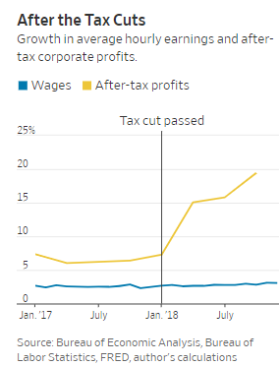

Figure 2: European economic sentiments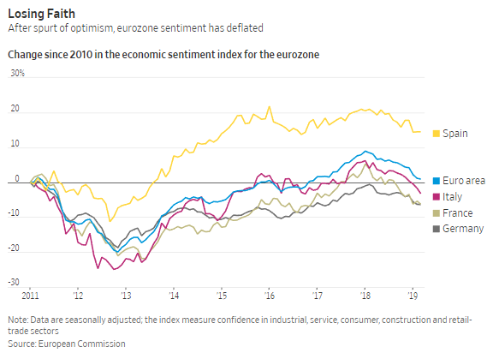

Figure 3: Phillips Curve--Flat lining 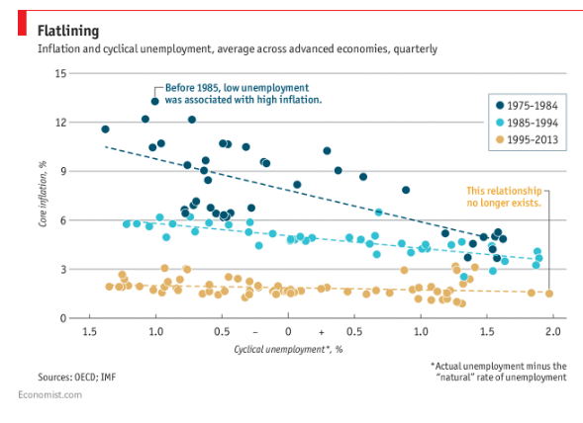

Figure 4: Estimates of the Longer-Run Neutral Rate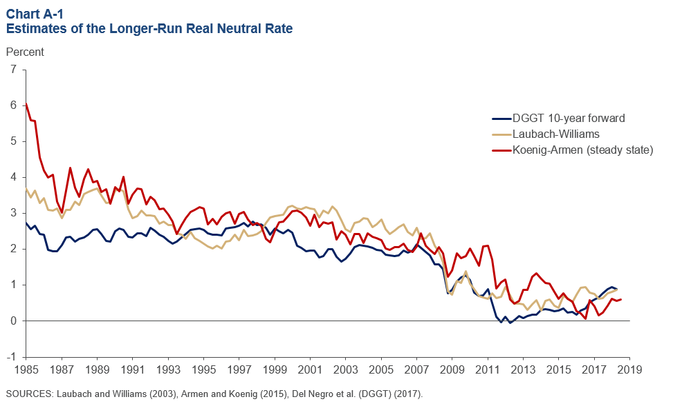

Figure 5: Where’s Neutral?

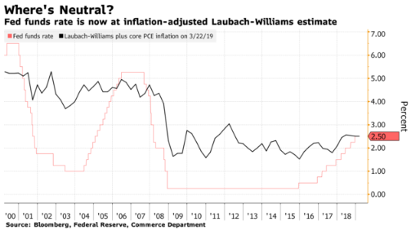

1. Timiraos, Nick. 2018. “Fed Raises Interest Rates, Sets Stage for Two More Increases in 2018.” The Wall Street Journal, June 13, 2018.
2. Phillips, Matt. “The Fed’s Rate-Raising Days Are Over. Wall Street Couldn’t Be Happier.” The New York Times, March 20, 2019.
3. Torry, Harriet. 2018. “U.S. Economy Grew at 3.5% Rate in Third Quarter” The Wall Street Journal, October 26, 2018.
4. Furman, Jason. 2018. “The Trump Tax Cuts Boosted Growth and Jobs, but at What Cost?”. The Wall Street Journal, December 18, 2018.
5. Politi, James. 2019. “Fed Sees no further rate rises in 2019.” Financial Times, March 20, 2019.
6. The Wall Street Journal, August 25, 2018. Global Monetary-Policy Officials Decries U.S. Trade Measures
7. Hannon, Paul. 2018 “ As Draghi Moves to Avert Recession, Eurozone Looks for a Jolt.” The Wall Street Journal, 03/08/2019.
8. Ip, Greg. 2019. “The Feds New Normal Looks Worrisome.” March 29, 2019
9. Kiernan, Paul. 2018. “U.S. Inflation Gauge Slid in January to Slowest Pace Since 2016.” March 29, 2019.
10. The Economist. 2017. “The Phillips Curve may be broken for good.” November 1, 2017.
11. Timiraos, Nick. 2019. “Fed Keeps Interest Rates Unchanged; Signals No More Increases Likely This Year. The Wall Street Journal, March 20, 2019.
12. Roseman, Adam. 2018. “A Recession Could Be Big Trouble for the Gig Economy.” Barron's, December 27, 2018.
13. Morath, Eric and Timiraos, Nick. 2018. “A Closer Look at the Wage Growth That Shook Markets.” The Wall Street Journal February 6, 2018.
14. Goldfarb, Sam and Louise-Ensign, Rachel. 2018. “Corporate Debt is Reaching Record Levels.” The Wall Street Journal, March 29, 2018.
15. Smialek, Jeanna. 2019. “Poor Man’s Monetary Policy’ Lurks in a Low-Neutral Rate Future” Bloomberg, March 26, 2019.
16. Timiraos, Nick. 2019. “Fed Keeps Interest Rates Unchanged; Signals No More Increases Likely This Year. The Wall Street Journal, March 20, 2019.
17. Fleming, Sam. 2019. “Donald Trump’s demands add to Federal Reserve interest rate headaches.” Financial Times April 7, 2019.
18. Fleming, Sam. 2019. “Donald Trump’s demands add to Federal Reserve interest rate headaches.” Financial Times April 7, 2019.
19. Moore, Stephen. 2019. “The Fed is a Threat to Growth.” The Wall Street Journal, March 13 2019.
20. Timiraos, Nick. 2019. “Fed Keeps Interest Rates Unchanged; Signals No More Increases Likely This Year. The Wall Street Journal, March 20, 2019.
21. Appelbaum, Binyamin. 2019. “Fed Signals End of Interest Rate Increases’ The New York Times, January 30, 2019.
22. Appelbaum, Binyamin. 2019. “Fed Signals End of Interest Rate Increases’ The New York Times, January 30, 2019.